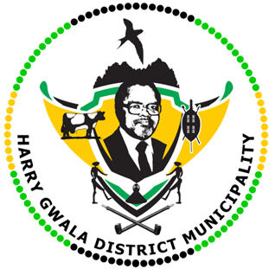
HARRY GWALA DISTRICT MUNICIPALITY
“Together We Deliver and Grow”
OFFICE OF THE MUNICIPAL MANAGER
40 Main Street, Private Bag X501, IXOPO 3276
Tel: (039) 834 8707 Fax: (039) 834 1701
Email: kunenes@harrygwaladm.gov.za
EXTERNAL ADVERTISEMENTS

INFRASTRUCTURE SERVICES DEPARTMENT
POST: EXPANDED PUBLIC WORKS PROGRAMME : DATA CLEANSING [22]

SALARY: R1 920.00 per month
DURATION: 12 MONTHS CONTRACT
JOB REQUIREMENTS
- Must be unemployed
- Must Have grade 12 with math’s literacy and accounting
- Must be computer literate
- Strictly reside within the Harry Gwala District Municipality and Specific ward
- Must not have been on the EPWP programme at Harry Gwala District Municipality for longer than 3 years
- Persons with disabilities are encouraged to apply
- The following demographic targets will be considered during the selection of Participants
- 60% Women
- 55% youth
- 2% Persons living with disabilities
KEY PERFORMANCE AREAS
Participants will be placed at the following Municipal premises of the Harry Gwala District Municipality:
- Statement sorting and updating of consumer information of the SOLAR system
- Assisting on filling application forms, updating consumer information on indigent register and solar system, physical verification of properties.
- Meter reading, sorting and delivery f water statements, capturing readings on Meter sheets (soft copies) assist on prepaid meter monitoring
SATELLITE (OFFICES) | Number of Participant
NDZ Satellite Office | 2
Kokstad Satellite | 13
uMzimkhulu | 2
Ixopo Main Office | 5

APPLICATIONS WITHOUT THE FOLLOWING DOCUMENTS WILL NOT BE CONSIDERED

- Curriculum vitae
- Copy of certified South African Identity document and any other qualification you may have
- Proof of residence for the specific ward you are applying for
- Recommendation letter from the Ward Councilor confirming the indigency

Enquires should be directed to the Municipal Works Unit on 039-834 8704/8742/8731/. No faxed or emailed applications will be accepted.
Applications must be submitted to the Municipal Manager for Attention: Mr N.E Biyase, Executive Director: Infrastructure Services, Harry Gwala District Municipality, Private Bag X 501, IXOPO, 3276, or can be hand delivered at 40 Main Street, IXOPO, 3276, to reach us no later than 15H00, 19 June 2023.
Further correspondence will be confined to shortlisted candidates. If you have not been contacted within four months of the closing date of the advertisement, please accept that your application has been unsuccessful.
NB: Canvassing with Councillors or Management will lead to immediate disqualification. Harry Gwala District Municipality subscribes to the National Equity Strategy.
The Council reserves the right not to continue with the appointment if it feels that no suitable candidates identified.

MR G.M SINEKE
MUNICIPAL MANAGER

